**Acknowledgements**

# We would like to take this opportunity to thank DIU, the CSE Department and specifically, **Lecturer Tamanna Yasmin** for helping and advising this project. Her help and guidance throughout the project development is greatly appreciated.

# Furthermore, we would also like to thank Prof. **Dr. Syed Akhter Hossain** for his help and guidance. Some of our friends also help us to make this project.

# Thank you every one.

**Introduction**

The Internet has established itself as one of the most frequently used means of exchanging information among people. Whether it is used for keeping in touch, doing business, research, shopping or entertainment, the Internet has become the most pervasive global social infrastructure. The electronic data transmission breaks the distance barrier.

 We have tried our best to make the complicated process of Online Music Store as simple as possible using wordpress & mysql. We have designed this website in such a way that user may not have any difficulty using this. This project is used by two types of users

1. Online Users.

2. Back Office Administrative Users

**Online Users:** Online user’s can browse music store based on their interest. Online website provides user’s detailed information about a music album, for example singers name, director, lyrics, popularity etc. User can subscribe to this website to play or download music online. Only subscribed users are allowed to download or play music online. User can subscribe for a year or month to month basis.

**Online users can perform following functions:**

1. Browse Music Store based on their interest.

2. Search for a music.

3. Download Music

4. Play Online Music

**Background History**

Before we make this project, we were making some projects like this in our previous semesters. We make Telephone Directory, Dictionary etc. We used Java & GUI to make these projects. Some images are given below

**Telephone Directory**

In this project we made telephone directory, which can add peoples name, address, phone number, email id etc. It could be updated by user. If user wants to delete an entry, he can do it.

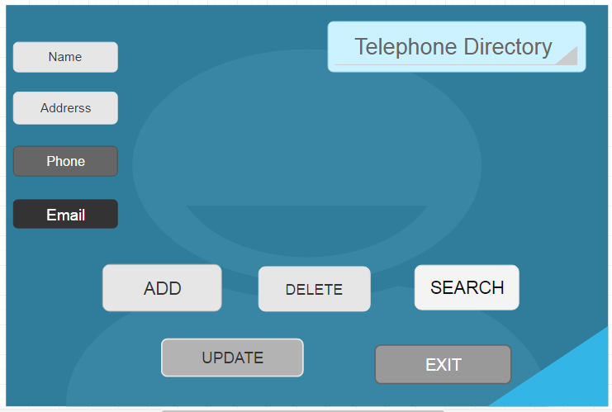

**Dictionary**

In this project we made a dictionary, which can show meaning of words, which is saved in dictionary. If the word is not saved in dictionary, It’s shows “Not found.” User can also see the whole word list.

